Computer Vision
Computer Vision:
Code:
import numpy as np

#Load the image
image=cv2.imread("C:\\CV\\images.jpg");

#Increase Brightness
image_float = image.astype(float)

# Increase the brightness
brightness_factor = 2.0 # Increase or decrease this value as needed
brightened_image = image_float * brightness_factor

#Decrease the Brightness
brightness_factor1 = 0.4 # Increase or decrease this value as needed
dark_image = image_float * brightness_factor1

# Clip the pixel values to the valid range [0, 255]
brightened_image = np.clip(brightened_image, 0, 255)
dark_image = np.clip(dark_image, 0, 255)

# Convert the image back to unsigned 8-bit integers
brightened_image = brightened_image.astype(np.uint8)
dark_image = dark_image.astype(np.uint8)

# Image Rotation
image_rotate = ndimage.rotate(image,45)

#Image translation
height, width = image.shape[:2] #Store height and Weight
T = np.float32([[1, 0, 100], [0, 1, 200]])
img_trans = cv2.warpAffine(image, T, (width, height))

#Show images
cv2.imshow("Original Image",image)
cv2.imshow("Brightened image",brightened_image)
cv2.imshow("Dark image",dark_image)
cv2.imshow("Rotated image",image_rotate)
cv2.imshow("Translated image",img_trans)
cv2.waitKey(0)
cv2.destroyAllWindows()

Output:
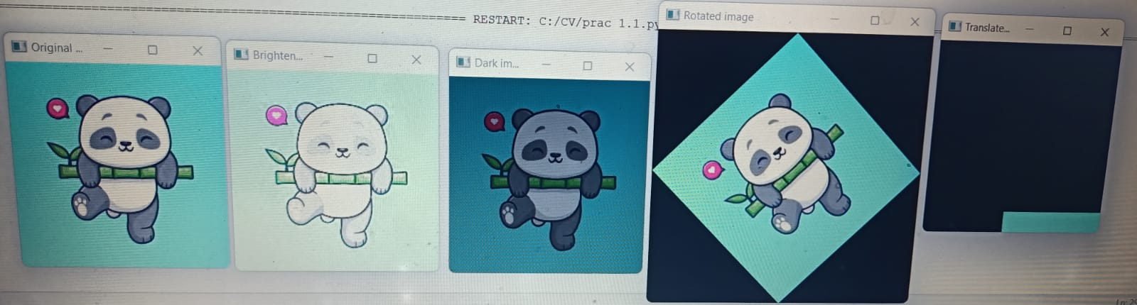

Histogram plotting
Code:
#Histogram plotting
import cv2
import matplotlib.pyplot as plt
# Step 2: Read the image
#img=cv2("C:\\CV\\images.jpg")
image_path = ("C:\\CV\\images.jpg")
img = cv2.imread(image_path)
# Step 3: Convert to grayscale (optional)
gray_img = cv2.cvtColor(img, cv2.COLOR_BGR2GRAY)
# Step 4: Calculate the histogram
hist = cv2.calcHist([gray_img], [0], None, [256], [0, 256])
# Step 5: Plot the histogram (optional)
plt.plot(hist)
plt.title('Histogram of Grayscale Image')
plt.xlabel('Pixel Intensity')
plt.ylabel('Frequency')
plt.show()
Output:
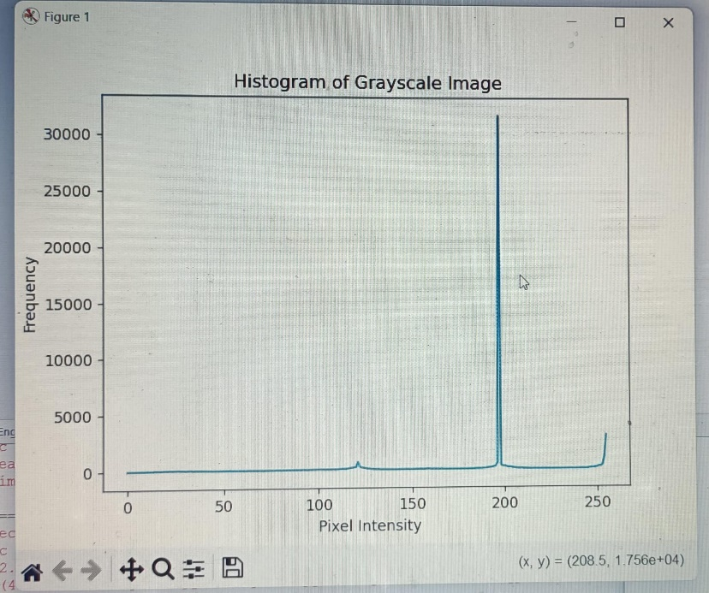

Histogram Equalization:
Code:
#Histogram equalization
# Import required Libraries
import cv2
from scipy import ndimage
import numpy as np
#Load the image
image=cv2.imread("C:\\CV\\images.jpg")
#Convert to Grayscale
gray = cv2.cvtColor(image, cv2.COLOR_BGR2GRAY)
#Perform Histogram Equalization
equalized_img = cv2.equalizeHist(gray)
cv2.imshow("Original Gray Image",gray)
cv2.imshow("Histogram Equalized Image",equalized_img)
cv2.waitKey(0)
cv2.destroyAllWindows()
Output:
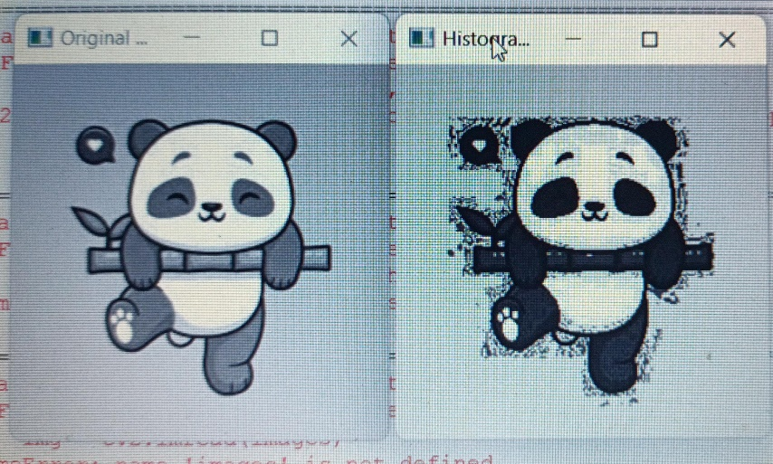

Filtering Methods:
- Low Filter:
Code:
import cv2
import numpy as np

def apply_average_filter(image_path, kernel_size):
# Read the image
image = cv2.imread(image_path)

# Apply the average filter
filtered_image = cv2.blur(image, (kernel_size, kernel_size))

return filtered_image

if __name__ == "__main__":
# Input image path and kernel size
input_image_path = ("C:\\CV\\images.jpg")
kernel_size = 10 # You can adjust the kernel size as needed.

# Apply the average filter
filtered_image = apply_average_filter(input_image_path, kernel_size)

# Display the original and filtered images
cv2.imshow("Original Image", cv2.imread(input_image_path))
cv2.imshow("Filtered Image", filtered_image)

# Wait for a key press and then close the windows
cv2.waitKey(0)
cv2.destroyAllWindows()
Output:
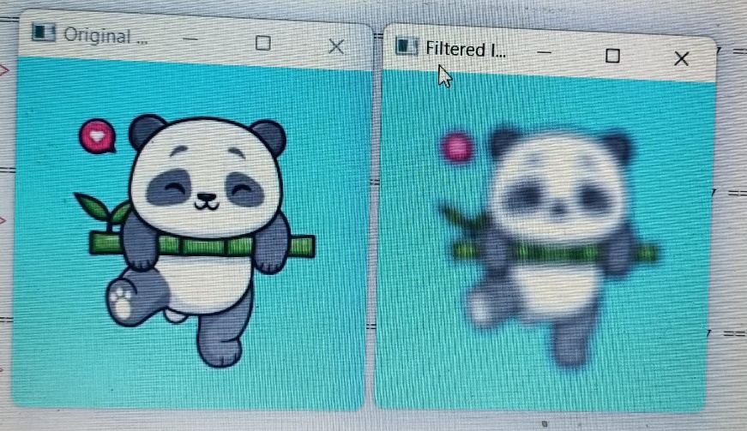
Guassian Filter:
Code:
import cv2

def apply_weighted_average_filter(image_path, kernel_size, sigmaX):
# Read the image
image = cv2.imread(image_path)

# Apply the weighted average filter (Gaussian blur)
filtered_image = cv2.GaussianBlur(image, (kernel_size, kernel_size), sigmaX)

return filtered_image

if __name__ == "__main__":
# Input image path, kernel size, and sigmaX (standard deviation in X direction)
input_image_path = ("C:\\CV\\images.jpg")
kernel_size = 5 # You can adjust the kernel size as needed.
sigmaX = 4 # You can adjust the sigmaX value for the Gaussian kernel.

# Apply the weighted average filter
filtered_image = apply_weighted_average_filter(input_image_path, kernel_size, sigmaX)

# Display the original and filtered images
cv2.imshow("Original Image", cv2.imread(input_image_path))
cv2.imshow("Filtered Image", filtered_image)

# Wait for a key press and then close the windows
cv2.waitKey(0)
cv2.destroyAllWindows()
Output:
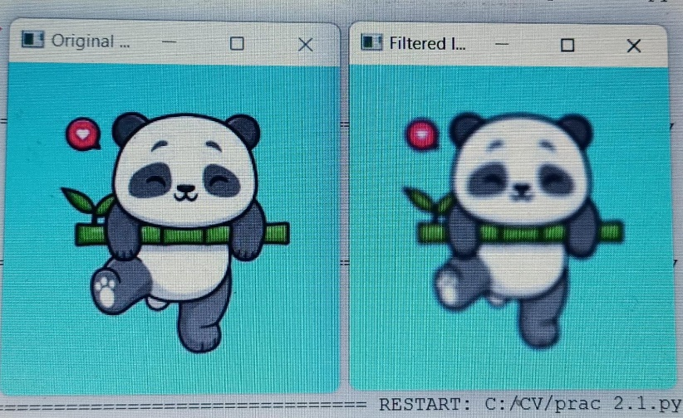

Median Filter:
Code:
import cv2
import numpy as np

# Load the image
image_path = ("C:\\CV\\images.jpg")
original_image = cv2.imread(image_path)

# Apply median filter with specified kernel size
kernel_size = 3 # Adjust this value to change the filter size
median_filtered_image = cv2.medianBlur(original_image, kernel_size)

# Display the original and filtered images
cv2.imshow('Original Image', original_image)
cv2.imshow('Median Filtered Image', median_filtered_image)

# Wait for a key press and close the windows
cv2.waitKey(0)
cv2.destroyAllWindows()
Output:
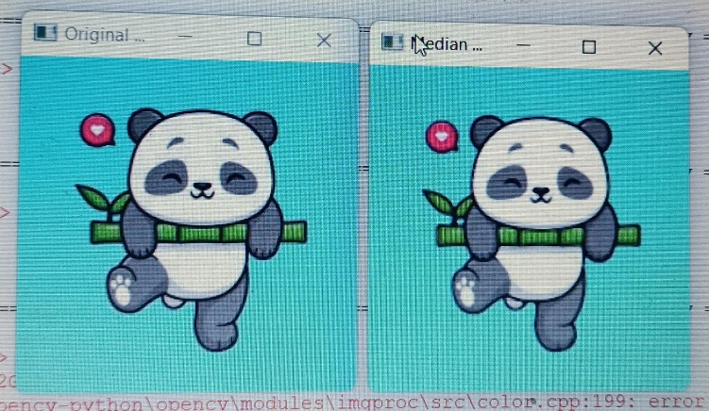

Sobel Filter:
Code:
import cv2
import numpy as np

# Load the image
image_path = ("C:\\CV\\images.jpg")
original_image = cv2.imread(image_path, cv2.IMREAD_GRAYSCALE)

# Check if the image was loaded successfully
if original_image is None:
print("Error loading the image.")
else:
# Apply Sobel filter in the x and y directions
sobel_x = cv2.Sobel(original_image, cv2.CV_64F, 1, 0, ksize=3)
sobel_y = cv2.Sobel(original_image, cv2.CV_64F, 0, 1, ksize=3)

# Convert the results to absolute values and then to 8-bit
sobel_x = cv2.convertScaleAbs(sobel_x)
sobel_y = cv2.convertScaleAbs(sobel_y)

# Combine the Sobel images to get the gradient magnitude
gradient_magnitude = cv2.addWeighted(sobel_x, 0.5, sobel_y, 0.5, 0)

# Display the original image and the gradient magnitude
cv2.imshow('Original Image', original_image)
cv2.imshow('Gradient Magnitude', gradient_magnitude)

# Wait for a key press and close the windows
cv2.waitKey(0)
cv2.destroyAllWindows()
Output:
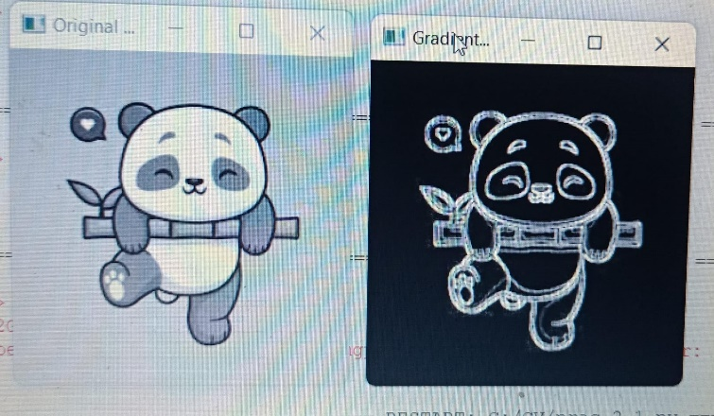

Prewitt Filter:
Code:
import cv2
import numpy as np
import matplotlib.pyplot as plt

def apply_prewitt_filter(image_path):
# Read the image in grayscale
img = cv2.imread(image_path, cv2.IMREAD_GRAYSCALE)
if img is None:
print("Error: Unable to load image.")
return
# Define Prewitt operator kernels
prewitt_x = np.array([[1, 0, -1], [1, 0, -1], [1, 0, -1]], dtype=np.float32)
prewitt_y = np.array([[1, 1, 1], [0, 0, 0], [-1, -1, -1]], dtype=np.float32)
# Apply filters
grad_x = cv2.filter2D(img, -1, prewitt_x)
grad_y = cv2.filter2D(img, -1, prewitt_y)
# Combine gradients
gradient_magnitude = cv2.magnitude(grad_x.astype(np.float32), grad_y.astype(np.float32))
gradient_magnitude = cv2.normalize(gradient_magnitude, None, 0, 255, cv2.NORM_MINMAX).astype(np.uint8)
# Display results
plt.figure(figsize=(10, 5))
plt.subplot(1, 3, 1), plt.imshow(img, cmap='gray'), plt.title('Original Image')
plt.subplot(1, 3, 2), plt.imshow(grad_x, cmap='gray'), plt.title('Prewitt X')
plt.subplot(1, 3, 3), plt.imshow(grad_y, cmap='gray'), plt.title('Prewitt Y')
plt.figure(figsize=(5, 5))
plt.imshow(gradient_magnitude, cmap='gray'), plt.title('Gradient Magnitude')
plt.show()

# Example usage
apply_prewitt_filter("C:\\CV\\images.jpg")
Output:
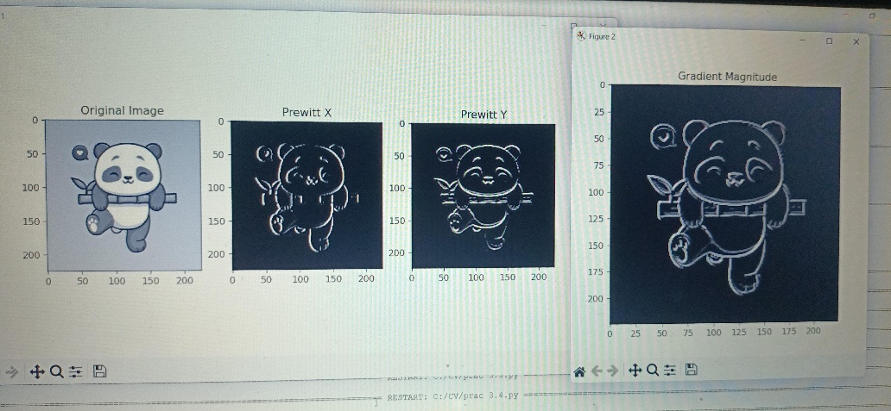
Laplacian Filter:
Code:
import cv2
import numpy as np
import matplotlib.pyplot as plt

# Read the image in grayscale
image = cv2.imread("C:\\CV\\images.jpg", cv2.IMREAD_GRAYSCALE)

# Apply the Laplacian filter
laplacian = cv2.Laplacian(image, cv2.CV_64F)

# Convert the result to uint8
laplacian = np.uint8(np.absolute(laplacian))

# Display the original and filtered images
plt.figure(figsize=(10, 5))
plt.subplot(1, 2, 1)
plt.title("Original Image")
plt.imshow(image, cmap='gray')
plt.axis('off')

plt.subplot(1, 2, 2)
plt.title("Laplacian Filtered Image")
plt.imshow(laplacian, cmap='gray')
plt.axis('off')

plt.show()

Output:
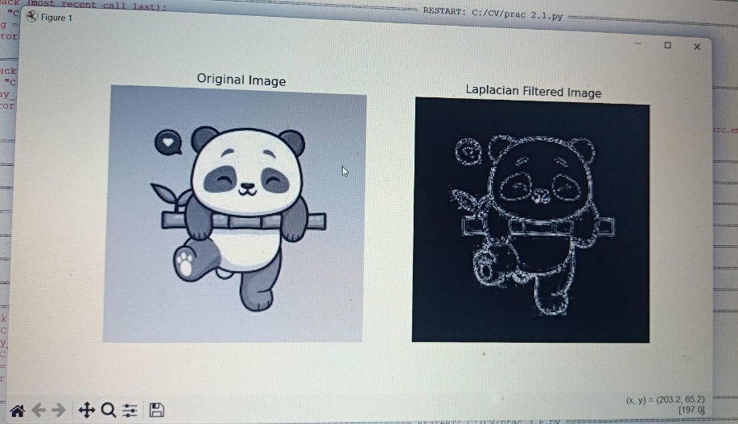

Converting rgb image to binary image using thresholding method:
Code:
import cv2

# Load the grayscale image
image = cv2.imread("C:\\CV\\images.jpg", cv2.IMREAD_GRAYSCALE)

# Apply thresholding
threshold_value = 150 # You can adjust this value
_, thresholded_image = cv2.threshold(image, threshold_value, 255, cv2.THRESH_BINARY)

# Display the thresholded image
cv2.imshow('Thresholded Image', thresholded_image)
cv2.waitKey(0)
cv2.destroyAllWindows()

#Converting rgb image to binary image using thresholding method

Output:
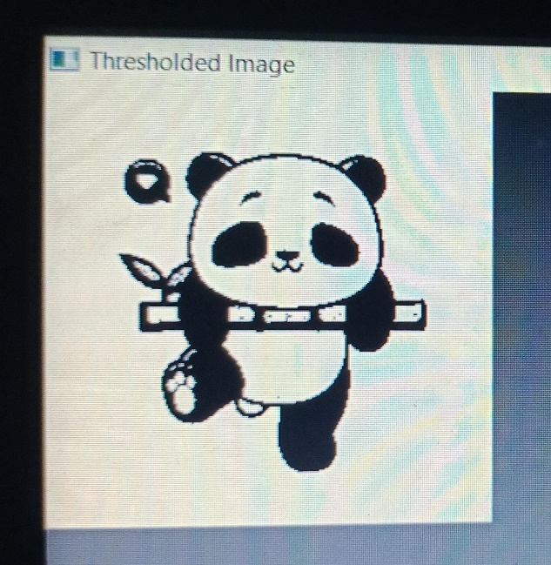

Color Model Conversion:
import cv2
import matplotlib.pyplot as plt
import numpy as np
# Load the image
image = cv2.imread("C:\\CV\\images.jpg")
# Convert to HSV (Hue= 0,360, Saturation=crominence,0 to 100%, Value=luminence,0 t0 255)
hsv_image = cv2.cvtColor(image, cv2.COLOR_BGR2HSV)
# Convert to LAB (CIELAB) color space b=+blue to -green, a = red to yellow
lab_image = cv2.cvtColor(image, cv2.COLOR_BGR2LAB)
# Convert to YCbCr y=intensity
ycbcr_image = cv2.cvtColor(image, cv2.COLOR_BGR2YCrCb)
# Convert to CMYK=cyan,magenta,yellow,black
#cmyk_image = cv2.cvtColor(rgb_image, cv2.COLOR_BGR2CMYK)
# Convert to YIQ =intensity,
yiq_image = np.zeros_like(image, dtype=np.float32)
yiq_image[:,:,0] = 0.299 * image[:,:,2] + 0.587 * image[:,:,1] + 0.114 * image[:,:,0]
yiq_image[:,:,1] = 0.596 * image[:,:,2] - 0.274 * image[:,:,1] - 0.322 * image[:,:,0]
yiq_image[:,:,2] = 0.211 * image[:,:,2] - 0.523 * image[:,:,1] + 0.312 * image[:,:,0]
yiq_image = np.clip(yiq_image, 0, 255).astype(np.uint8)
# Display the original and converted images
plt.figure(figsize=(10, 8))
plt.subplot(4, 2, 1)
plt.imshow(cv2.cvtColor(image, cv2.COLOR_BGR2RGB))
plt.title('Original Image')
plt.axis("off")
plt.subplot(4, 2, 2)
plt.imshow(cv2.cvtColor(hsv_image, cv2.COLOR_BGR2RGB))
plt.title('HSV Image')
plt.axis("off")
plt.subplot(4, 2, 3)
plt.imshow(cv2.cvtColor(image, cv2.COLOR_BGR2RGB))
plt.title('Original Image')
plt.axis("off")
plt.subplot(4, 2, 4)
plt.imshow(cv2.cvtColor(lab_image, cv2.COLOR_BGR2RGB))
plt.title('LAB Image')
plt.axis("off")
plt.subplot(4, 2, 5)
plt.imshow(cv2.cvtColor(image, cv2.COLOR_BGR2RGB))
plt.title('Original Image')
plt.axis("off")
plt.subplot(4, 2, 6)
plt.imshow(cv2.cvtColor(ycbcr_image, cv2.COLOR_BGR2RGB))
plt.title('YCbCr Image')
plt.axis("off")
plt.subplot(4, 2, 7)
plt.imshow(cv2.cvtColor(image, cv2.COLOR_BGR2RGB))
plt.title('Original Image')
plt.axis("off")
plt.subplot(4, 2, 8)
plt.imshow(cv2.cvtColor(yiq_image, cv2.COLOR_BGR2RGB))
plt.title('YIQ Image')
plt.axis("off")
plt.show()
Output:
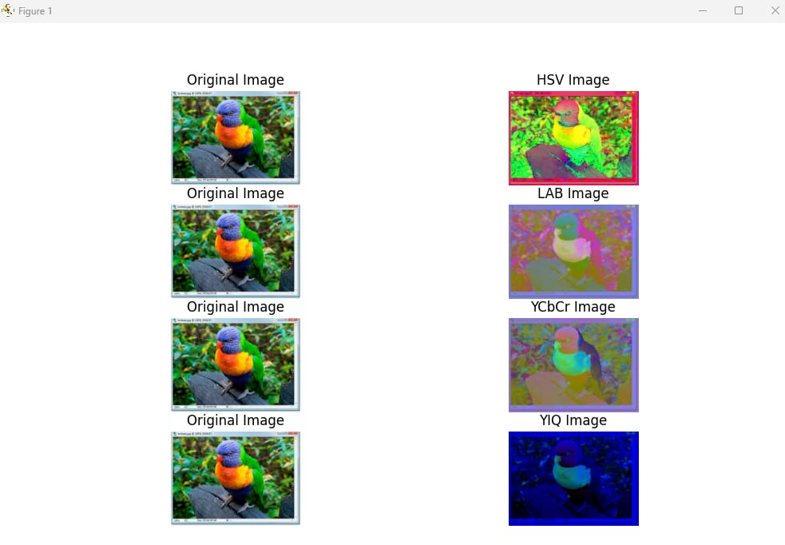

Morphological Operations:
Code:
import cv2
import numpy as np
import matplotlib.pyplot as plt
from skimage.morphology import skeletonize
# Read the image in grayscale
og_image = cv2.imread(r"D:\\CV\\images.png")
image = cv2.imread(r"D:\\CV\\images.png", cv2.IMREAD_GRAYSCALE)
# Apply a binary thresholding operation
threshold_value = 150
_, binary_image = cv2.threshold(image, threshold_value, 255, cv2.THRESH_BINARY)
# Create a kernel for morphological operations
kernel = np.ones((5, 5), np.uint8)
# Apply morphological operations
erosion = cv2.erode(binary_image, kernel, iterations=1)
dilation = cv2.dilate(binary_image, kernel, iterations=1)
opening = cv2.dilate(erosion, kernel, iterations=1)
closing = cv2.erode(dilation, kernel, iterations=1)
# Normalize the binary image (0 or 1 values) for skeletonization
binary_norm = binary_image // 255 # Convert to 0 and 1
skeleton = skeletonize(binary_norm) # Apply thinning
# Convert skeleton back to uint8 (255 for "1" and 0 for "0")
skeleton = (skeleton * 255).astype(np.uint8)
# Display the images
# cv2.imshow("Original Image", image)
# cv2.imshow("Grey Image", image)
# cv2.imshow("Binary Image", binary_image)
# cv2.imshow("Erosion Image", erosion)
# cv2.imshow("Dilation Image", dilation)
# cv2.imshow("Opening Image", opening)
# cv2.imshow("Closing Image", closing)
# cv2.imshow("Skeleton Image", skeleton)
plt.subplot(4, 2, 1)
plt.title("Original Image")
plt.imshow(og_image)
plt.axis('off')
plt.subplot(4, 2, 2)
plt.title("Grayscale Image")
plt.imshow(image)
plt.axis('off')
plt.subplot(4, 2, 3)
plt.title("Binary Image")
plt.imshow(binary_image)
plt.axis('off')
plt.subplot(4, 2, 4)
plt.title("Erosion Image")
plt.imshow(erosion)
plt.axis('off')
plt.subplot(4, 2, 5)
plt.title("Dilation Image")
plt.imshow(dilation)
plt.axis('off')
plt.subplot(4, 2, 6)
plt.title("Opening Image")
plt.imshow(opening)
plt.axis('off')
plt.subplot(4, 2, 7)
plt.title("Closing Image")
plt.imshow(closing)
plt.axis('off')
plt.subplot(4, 2, 8)
plt.title("Skeleton Image")
plt.imshow(skeleton)
plt.axis('off')
plt.show()
cv2.waitKey(0)
cv2.destroyAllWindows()
Output:
